**How to read your prescription bottle**

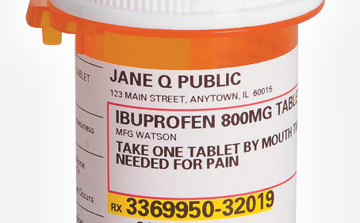

**Medication 🡺 🡼 Medication Strength**

**Directions for use 🡺**

**Important information to note when writing down your medications:**

* Medication:
  + Be sure to spell your medication correctly- small spelling errors can completely change the medication
* Strength:
  + How many milligrams (mg), micrograms (mcg), grams (gm), units, ect. are you taking?
* Directions for use:
  + How many tablets?
  + How often are you suppose to take it?

**When writing them out - use this format:**

Ibuprofen 800mg 1 tablet every 8 hrs as needed for pain